**CHAPTER 1**

**PROJECT DEFINITION**

* 1. **INTRODUCTION**

The Furniture Shop now stands on it’s 36th year with two stores found in Bacoor and Silang, Cavite. The shop offers high quality furniture that goes from simple and classic to one very luxurious design.

The business is owned and managed by a family, but mostly by the parents who still list and writes the orders made per day and the receipts and bill per transaction. It’s difficult processing the transaction due to the unorganized stack of charts and voluminous brochures. The shop also uses the forms improperly which leads to difficult retrieval of order records.

The proponents aim to provide a Web-Based Management system entitled, Furniture Shop Management System. This system will help the family in making faster transactions.

It will help them in storing and retrieving information, enhancing the security of their records. The customers will also find it more convenient to choose a furnitureby sending their desired design with the customization feature. With this system, the furniture shop that is running for 36 years now, will keep up with the rapidly changing society and developing technology.

* 1. **BUSINESS CASE**
     1. **BACKGROUND OF THE ORGANIZATION**

The Furniture Shop makes high quality furniture made of narra wood with designs that goes from simple and classic to a very luxurious one. They offer furniture generously made of narra and of high quality fabrics imported from other countries. The shop creates furniture for display and for walk-in customers to see and purchase. They accept orders with designs picked from their brochures or customized designs specified or brought by the customer.

The 36 year old running business now has two stores; both stores are managed by the family members themselves. Josephine BonayonBaraquiel, one of the owners, proposed the idea of making furniture shop to her husband because she herself is a daughter of a furniture maker. Josephine used to help her parents way back when she was in their care. Her parents influenced her in every way and together with her husband they build the Furniture shop together.

This business is the reason they got to where they are now, from a small shop at vicinity in Albay, Bicol to owning two stores located nearby the capital city of the country. The Furniture Shop is also the reason how they manage to send their six children to decent universities and now their children are working at great companies and is helping them from time to time.

The Furniture shop’s number one priority in furniture making is ensuring that the furniture they make is of high quality and can be considered world class. They also wanted to join the bandwagon of online shops in the country to be part of this rapidly changing society.

* + 1. **PROJECT OVERVIEW**

The project aims to help the said Furniture Shop in making their transactions faster, easier and help them keep pace with the rapidly changing society by providing them a web-based system. This web-based system will have a website and an admin interface. The admin interface is where the manager can update their featured furniture, add and remove furniture and manage orders made personally or through the website. The website will display all furniture the shop can offer. The customer can easily order furniture just by browsing through the website and the manager will find it easy to manage orders and produce the customers’ bills and receipts.

It will also help the customers choose design on their perspective by sending their own design in our customization feature. With the system the manager can easily store and retrieve information, thus minimizing the time for looking upon the client’s record every time they deliver.

* + 1. **PROJECT CONSTRAINTS**

The constraints considered by the proponents are the following:

* Time frame given for the project is 10 months, limited amount of time to build the system.
* The scope of the project covers maintainance and transaction processes of the business.
* The proponents are currently students with limited source of income. It is certain that they cannot invest financially.

.

* + 1. **PROJECT ASSUMPTIONS**
* **The Project will be finished on time**

The fully-functional system project will be finished on time with no errors and bugs.

* **The project team will able to acquire all the information and documents needed**

The client will be able to provide all necessary documents and information for the Project Team to comply with the requirements of the project and be able to provide them a running system that functions accurately.

* **User Acceptance**

The client will be satisfied with the final outcome of the project. The project will lighten the works of the users, their transaction will be faster and provide a better service to their customers.

**1.3. SCOPE AND LIMITATION**

The business processes of the furniture shop includes managing of orders, create billing and collections and production tracking.

Transaction includes point of sales, raw materials management, delivery tracking and production management. The system will also have a feature of customization which allows the customers to send their own design of the furniture. Maintenance of the fields needed for the transactions will be covered. The system also produces queries and reports.

The system will not cover the business' full inventory transaction of raw materials.

**1.4. METHODS USED IN THE STUDY**

**1.4.1 Data Gathering Techniques**

* **Observation**

The proponents observed the business environment and how they do things thus making it easier for us to know their problems.

* **Personal Interview**

The proponents conducted an interview to gather data needed for this project. This serves as the way to obtain useful information to the people who know the business very well.

* **Document Analysis**

The forms we gathered will be analyzed to understand the business and know what data are needed for the transactions.

**1.4.2 Software Process Model**

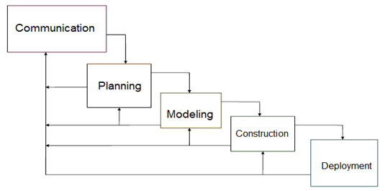

**Figure 1.1 Waterfall Model with Feedback**

The teamused the Waterfall Model with Feedback as a model used in visualizing the step by step process the group is going to take to finish the project on the scheduled time. The Waterfall Model with Feedback is a simple and easy to use model because of it’s rigidity. Each phases has a specific deliverable and a review process therefore after making progress on the project we can go back to the client and ask if what we produce is accurate according to their business rules and processes.

**CHAPTER 2**

**FUNCTIONAL SPECIFICATION REPORT**

**2.1 DATA REQUIREMENTS**

**2.1.1 FORMS**

**2.1.1.1 LIST OF FORMS**

|  |  |  |  |
| --- | --- | --- | --- |
| **Form #** | **Form Name** | **Description** | **User** |
| F1 | Sales Invoice | This contains the customer information, order information, order specification and payment information. This serves as the contract and the bill. | Manager, Customer |
| F2 | Job Order | This contains the details of the ordered furniture the manufacturer should follow. | Manager, Manufacturer |
| F3 | Delivery Receipt | It contains delivery information, order information and payment information. This is given to the delivery man and later on passed to the customer as final receipt. | Manager, Customer, Delivery Man, |
| F4 | Official Receipt | This contains the payment details of the customer. This is given to the customer every payment made. | Manager, Customer |

***Table 2.1 List of Forms***

**2.1.1.2 SAMPLE OF FORMS**

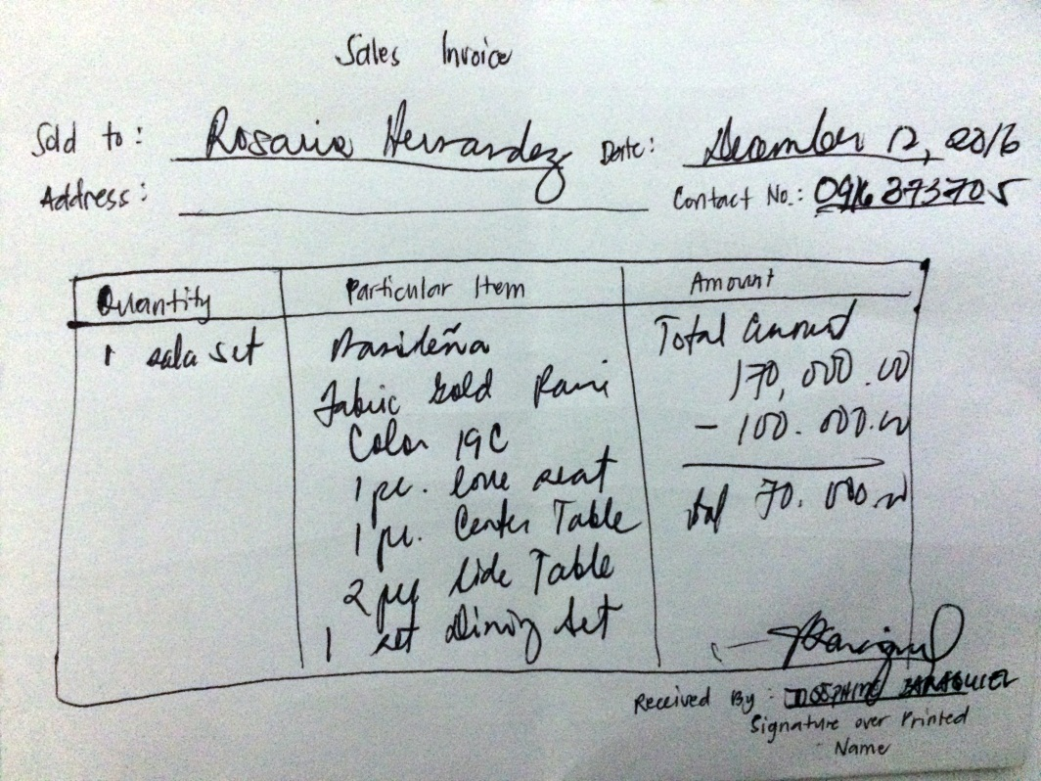

***Figure 2.1 Sample Sales Invoice Format***

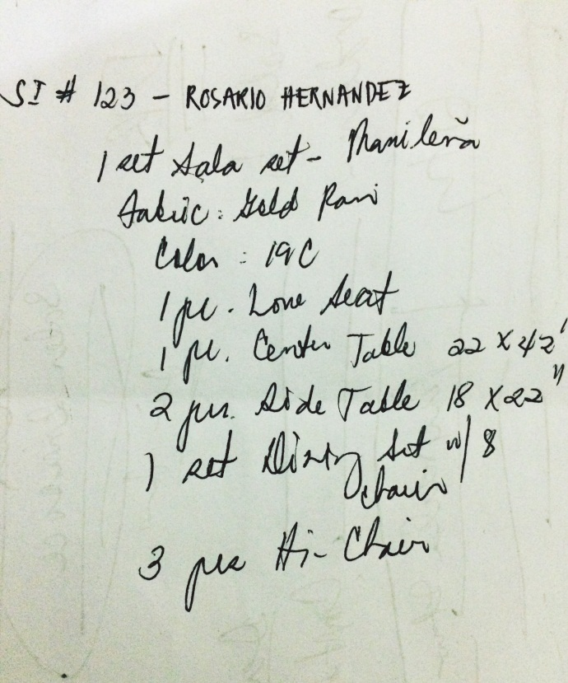

***Figure 2.2 Sample Job Order Format***

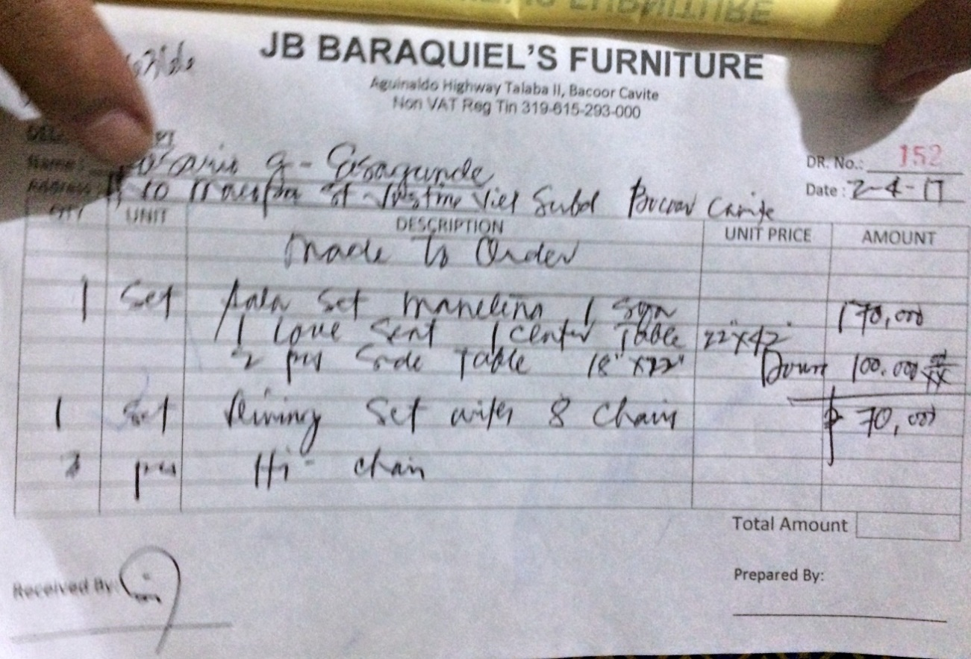

***Figure 2.3 Sample Delivery Receipt***

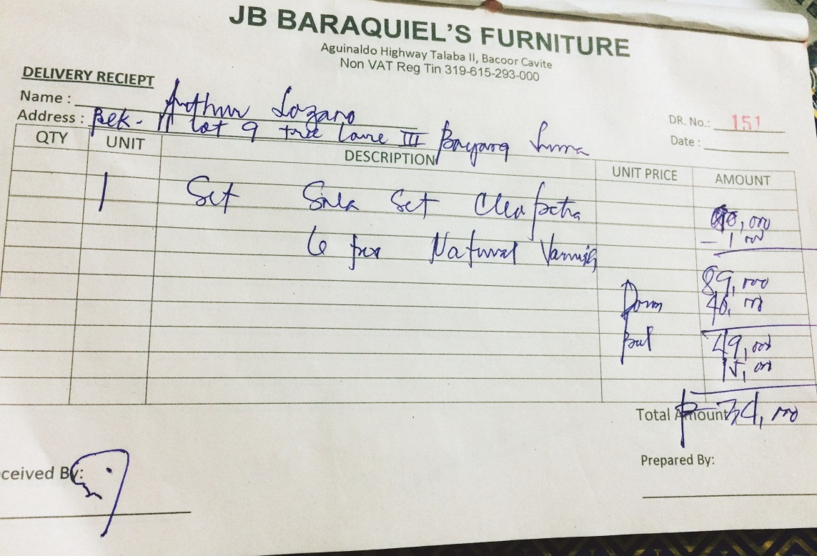

***Figure 2.3.1 Sample Delivery Receipt***

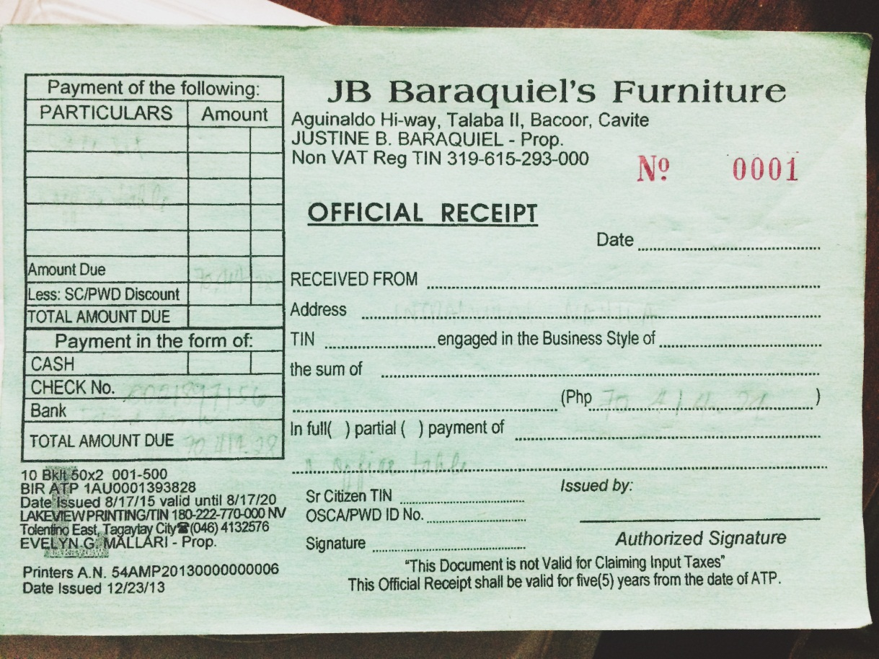

***Figure 2.4 Sample Official Receipt***

**2.1.2 REPORTS**

**2.1.2.1 LIST OF REPORTS**

|  |  |  |  |
| --- | --- | --- | --- |
| **Report #** | **Report Name** | **Description** | **Frequency** |
| R1 | Sales Report | Contains the daily record of the furniture sold to customers. | Daily, Monthly, Annually |

***Table 2.2 List of Reports***

**2.1.2.2 SAMPLE REPORTS**

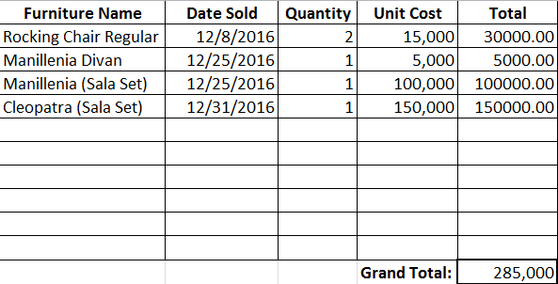

***Figure 2.5 Sample Sales Report Format***

**2.2 POLICIES AND PROCEDURES**

**2.2.1 PROCEDURES**

**2.2.1.1 CONTEXT DIAGRAM**

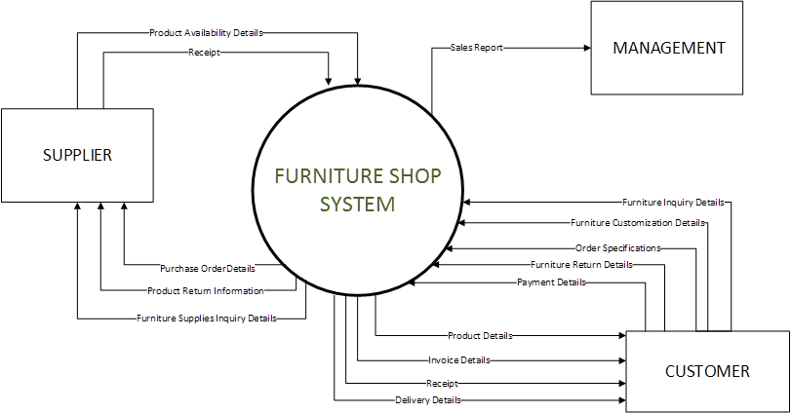

***Figure 2.6 Context Diagram***

**2.2.1.2 LEVEL 1 DFD**

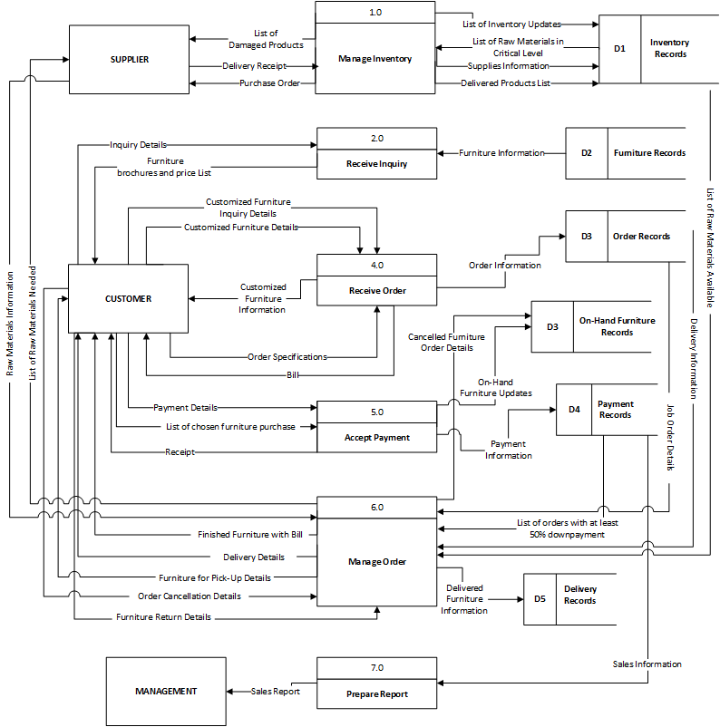

***Figure 2.7 Level 1 Data Flow Diagram***

**2.2.2 POLICIES**

**2.2.2.1 BUSINESS REQUIREMENTS**

|  |  |
| --- | --- |
| **BR NO.** | **BUSINESS REQUIREMENT** |
| **BR001** | The production of furniture will begin once the customer paid a down payment of at least 50% of the total amount of the ordered furniture. |
| **BR002** | A storage fee of PHP 500 pesos will be added to the total balance if furniture is not claimed or is fully paid on or before the day the contract will end. |
| **BR003** | A detailed description and specification is needed for customized furniture. |
| **BR004** | Damage on furniture caused by natural disaster and by improper use or maintenance is not covered on the warranty. |
| **BR006** | Official receipt must be presented to acquire warranty. |

***Table 2.3 Business Requirement***

**2.2.2.2 BUSINESS POLICIES**

|  |  |
| --- | --- |
| **BP NO.** | **BUSINESS POLICIES** |
| **BP01** | The customer must pay at least 50% of the total price of the furniture ordered for the production of furniture to begin. |
| **BP02** | On-hand furniture must be fully paid upon acquisition. |
| **BP03** | Furniture must be claimed, paid or delivered on or before the end of the contract. |
| **BP04** | If a customer cancelled his/her order the down payment will be given back deducting the storage fee once the furniture has been sold. |
| **BP05** | If ordered furniture is not claimed within 1 month (30 days) and 1 week after the contract’s expiration the management has the right to resell the furniture. |
| **BP06** | The price of a customized furniture will be decided by the management |
| **BP07** | The furniture will be replaced or repaired if found broken upon delivery. |
| **BP08** | Six months warranty is given to all furniture. |

***Table 2.4 Business Policies***

**2.3 PROBLEM ANALYSIS**

**2.3.1 FISHBONE**

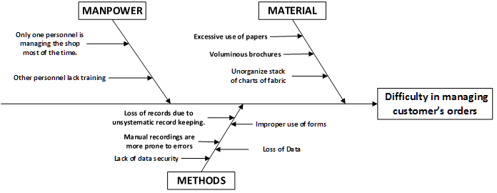

***Figure 2.8 Fishbone Diagram of the Furniture Shop***

**2.3.2 PROBLEMS AND REQUIREMENTS**

|  |  |  |  |
| --- | --- | --- | --- |
| **Ref. Page** | **No.** | **Problem** | **Requirements** |
| 16 | 1 | Only one personnel is managing the shop most of the time. | Capability to efficiently manage orders. |
| 16 | 2 | Loss of records due to unsystematic record keeping. | Manage records systematically. |
| 16 | 3 | Lack of data security. | Ability to restrict access of data. |
| 16 | 4 | Excessive use of papers. | Capability to minimize,if not eliminate the use of paper. |
| 16 | 5 | Voluminous brochures. | Provides categorized products for display. |
| 16 | 6 | Improper use of forms. | Capability to identify the form/s to be used in the given transactions. |
| 16 | 7 | Loss of data. | Ability to keep data for every transactions made. |

***Table 2.5 Problems and Requirements***

**2.3.3 CONCLUSIONS**

The Furniture Shop offers high quality furniture made of narra wood. They aim to provide high quality furniture that goes from simple and classic to one very luxurious design, not just to citizens of Cavite but as much as possible, to the whole country.

As of now, the said Furniture shop uses the manual process of recording data, the manager will write the customer information, order information, billing information, and they allow the client to customize their own designs of furniture. A lot of data is being stored so the shop uses excessive papers, papers that are being stored on the file cabinets around their small office. They also use their forms improperly providing confusing records that leads to difficulty in managing customer’s orders.

**2.3.3 RECOMMENDATIONS**

In order to help the business resolve the problems stated above, the proponents recommend the Furniture Shop to have a Web-Based system that will help them manage order and the information that is going in and out of the shop, at the same time will help them promote their products and reach customers on a farther vicinity. The Filipiniana Furniture Shop Management System will have the following sub-systems:

The Furniture Ordering Management System, this sub-system will help the manager in managing the orders. The customer will be able to order furniture easily. Additionally, this sub-system also has a customization feature where the customer can customize furniture to their own liking. In this sub-system, all on-hand furniture and furniture available for pre-order will be displayed per category for the customer to easily choose. Once, the customer is done ordering he can just check-out and proceed to billing. The customer information will be needed for verification.

The Billing and Collection System, this sub-system will compute the total amount of furniture in the customer’s orders. After checking-out the customer will receive an email from the furniture shop containing his bill and where and how the customer can pay. If the ordered furniture is on-hand and the customer has paid for it the furniture will be delivered. If it’s pre-order, the production of the ordered furniture will begin once the customer has paid 50% of the total amount. However, the order will be considered null and void if the customer fails to pay within seven days. This sub-system will help in producing receipt easily, lessening the time needed for writing.

The Production Monitoring System, this sub-system will track the production of an order. After the transaction is settled, the manager will issue job order form for the manufacturers, this job order form contains the specifications and descriptions of the furniture to be made. This sub-system will enable the manager to view and update production progress information, which includes status of the production, the handler who will make the furniture, and the production progress percentage of the furniture.

**CHAPTER 3**

**PROPOSED SYSTEM DEFINITION**

**3.1 Requirements-Features Matrix**

|  |  |  |  |  |  |  |  |
| --- | --- | --- | --- | --- | --- | --- | --- |
| **Features/ Requirements** | **REQ1.**  *Capability to efficiently manage orders.* | **REQ2.**  *Manage records in a system-atically.* | **REQ3.**  *Ability to restrict access of data.* | **REQ4.**  *Capability to minimize, if not eliminate the use of paper.* | **REQ5.** *Provides categorized products for display.* | **REQ6.**  *Capability to identify the form/s to be used in the given transactions* | **REQ7.**  *Ability to keep data for every transactions made.* |
| **FEAT1.** *Web-based ordering transaction* | **✔** | **✔** | **✔** | **✔** | **✔** | **✔** | **✔** |
| **FEAT2.**  *Tracking of production.* | **✔** | **✔** | **✔** | **✔** |  | **✔** | **✔** |
| **FEAT3.**  *Tracking of delivery.* | **✔** | **✔** | **✔** | **✔** |  | **✔** | **✔** |
| **FEAT4.**  *Inventory of Raw Materials.* | **✔** | **✔** | **✔** | **✔** |  |  | **✔** |
| **FEAT5.** *Customiza-*  *tion of designs.* | **✔** | **✔** |  | **✔** | **✔** | **✔** | **✔** |
| **FEAT6.**  *Ability to produce reports.* |  | **✔** | **✔** | **✔** |  |  | **✔** |

***Table 3.1 Feature-Requirements Matrix***

**3.2 Functional Specification**

**3.2.1 System Boundaries**

**3.2.2 System Use Case Diagram**

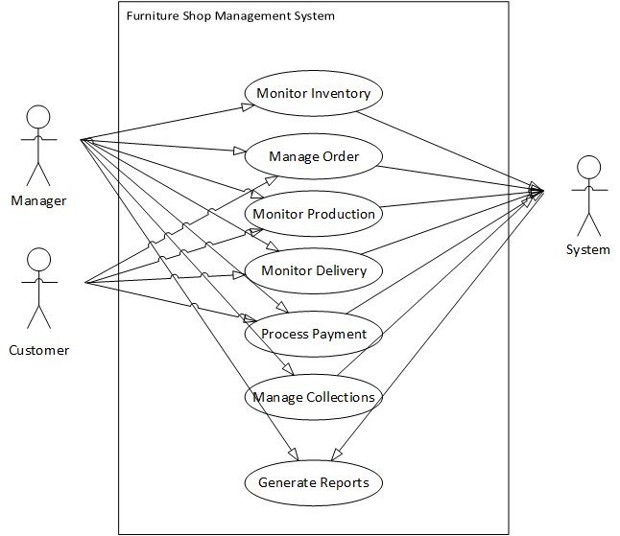

***Figure 3.1 Top level Use case***

**3.2.3 Detailed per Use Case**

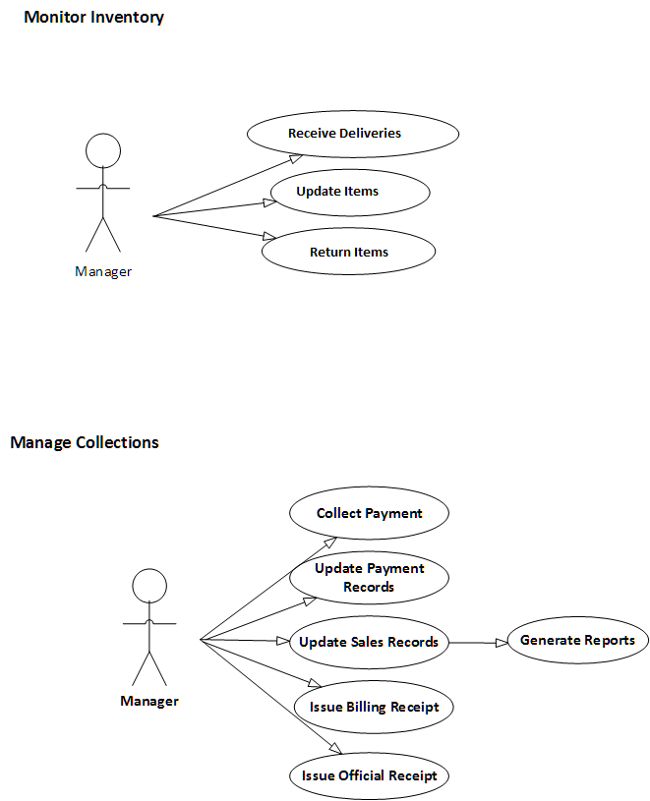

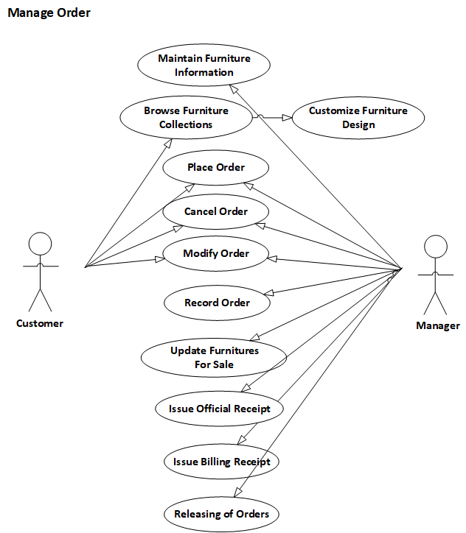

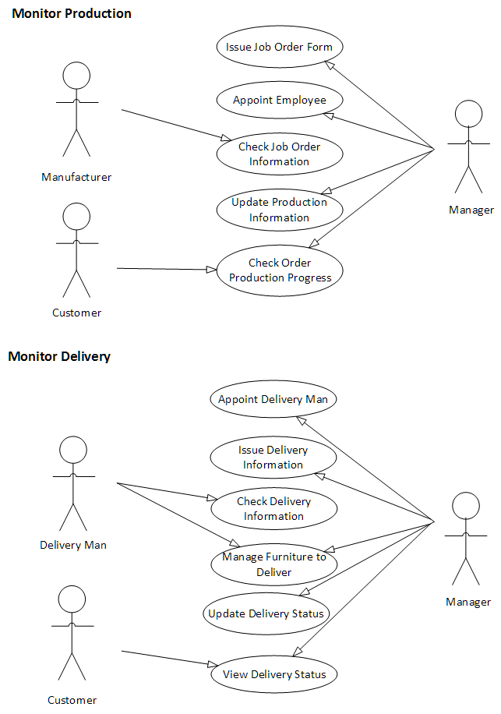

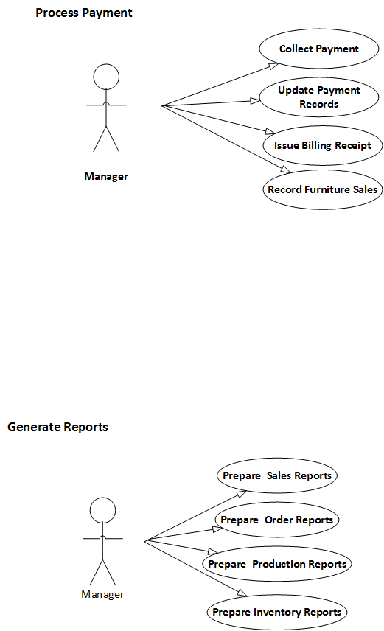

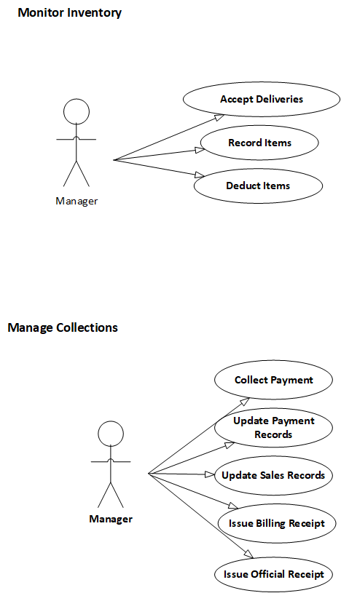

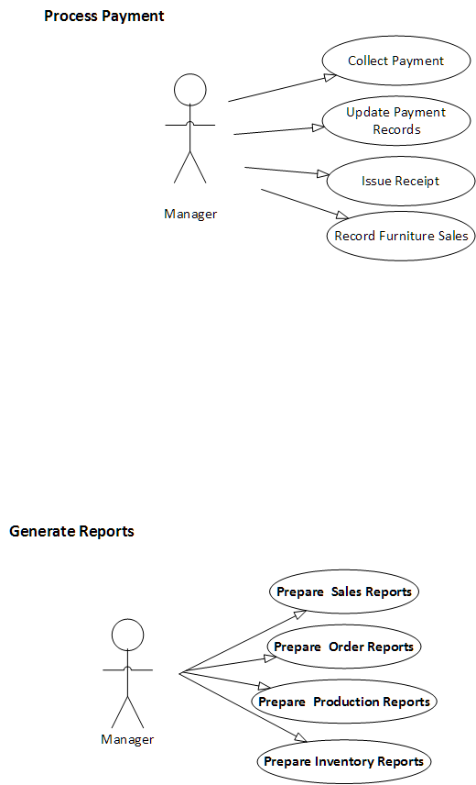

‘

**3.3.4 Use Case Description**

|  |  |
| --- | --- |
| Use Case Name: | **Maintain Furniture Information** |
| Actor/s: | Management |
| Purpose: | To maintain information of furniture |
| Brief Description: | Display of products information |
| Pre-condition: | Must be an authorized admin. |
| Post- condition: | Maintain information about furniture. |

|  |  |
| --- | --- |
| **BASIC FLOW:** | |
| ACTION | SYSTEM RESPONSE |
| 1. Admin accesses products. | 2. Displays furniture and its informations. |
| 3. Click update button. | 4. Enables admin to edit furniture information. |
| 5. Click save. | 6. Displays updated furniture information. |

|  |  |
| --- | --- |
| Use Case Name: | **Browse Furniture** |
| Actor/s: | Customer |
| Purpose: | To have a preview of the products being sold. |
| Brief Description: | Display of products being sold. |
| Pre-condition: | Must not be an authorized admin. |
| Post- condition: |  |

|  |  |
| --- | --- |
| **BASIC FLOW:** | |
| ACTION | SYSTEM RESPONSE |
| 1. Admin accesses products. | 2. Displays the products being sold. |
| 3. Click view button. | 4. Displays all the information about a particular product. |

|  |  |
| --- | --- |
| Use Case Name: | **Place Order** |
| Actor/s: | Management/Customer |
| Purpose: | To make an order request. |
| Brief Description: | Requesting order. |
| Pre-condition: | Must have an account. |
| Post- condition: | Update Order Information. |

|  |  |
| --- | --- |
| **BASIC FLOW:** | |
| ACTION | SYSTEM RESPONSE |
| 1. Admin or Customer accesses products. | 2. Displays the products being sold. |
| 3. Click cart button. | 4. Add the selected product to cart. |
| 5. Click proceed to checkout button. | 6. Enables user to put information such as the delivery information, payment information, customer information, and remarks about the order information. |
| 7. Click Save & Print | 8. Saves the order to Orders. |

|  |  |
| --- | --- |
| Use Case Name: | **Cancel Order** |
| Actor/s: | Management/Customer |
| Purpose: | To cancel an order. |
| Brief Description: | Cancels an order. |
| Pre-condition: | Must have an account. Must have an order. |
| Post- condition: | Update Order Information. |

|  |  |
| --- | --- |
| **BASIC FLOW:** | |
| ACTION | SYSTEM RESPONSE |
| 1. Admin or Customer accesses orders. | 2. Displays all the user's orders. |
| 3. Click Update button. | 4. Enables the user to modify his orders. |
| 5. Click cancel order button. | 6. Enables the user to cite out the reason for cancelling. |
| 7. Click cancel order button | 8. Deletes the order from Orders. |

|  |  |
| --- | --- |
| Use Case Name: | **Modify Order** |
| Actor/s: | Management/Customer |
| Purpose: | To allow the user to change its ordered products. |
| Brief Description: | Changes the ordered products. |
| Pre-condition: | Must have an account. Must have an order. |
| Post- condition: | Update Order Information. |

|  |  |
| --- | --- |
| **BASIC FLOW:** | |
| ACTION | SYSTEM RESPONSE |
| 1. Admin or Customer accesses orders. | 2. Displays all the user's orders. |
| 3. Click Update button. | 4. Enables the user to modify his orders. |
| 5. Click Save button | 6. Saves the new order information. |

|  |  |
| --- | --- |
| Use Case Name: | **Record Order** |
| Actor/s: | Management |
| Purpose: | Allows the management to accept order requests. |
| Brief Description: | Accepting of order requests. |
| Pre-condition: | Must have an order. |
| Post- condition: | Update Order Information. |

|  |  |
| --- | --- |
| **BASIC FLOW:** | |
| ACTION | SYSTEM RESPONSE |
| 1. Admin accesses orders. | 2. Displays all the user's orders. |
| 3. Click accept button. | 4. Accepts an order. |

|  |  |
| --- | --- |
| Use Case Name: | **Update Furntitures for sale** |
| Actor/s: | Management |
| Purpose: | Allows the management to update furnitures. |
| Brief Description: | Updating furnitures for sale |
| Pre-condition: | Must update furnitures for sale. |
| Post- condition: | Update furnitures |

|  |  |
| --- | --- |
| **BASIC FLOW:** | |
| ACTION | SYSTEM RESPONSE |
| 1. Admin accesses orders. | 2. Displays all the furnitures for sale. |
| 3. Click Update button. | 4. Enables the admin to modify furniture information. |
| 5. Click Save button | 6. Saves the updated furniture information. |

**Monitor Production**

|  |  |
| --- | --- |
| Use case Name: | **Update Production Information** |
| Actor/s: | Management |
| Purpose: | Monitoring the production of the furniture. |
| Brief Description: | The use case displays Production details for every placed orders. |
| Pre-condition/s: | User must be an authorized admin. |
| Post-condition/s: | Production phase must be updated |

|  |  |
| --- | --- |
| **BASIC FLOW** | |
| ACTION EVENT | SYSTEM RESPONSE |
| 1. Admin accesses Production Tracking in Transactions. | 1. Orders that are undergoing or pending for production is displayed. |
| 1. Click View Details | 1. Display the ordered furniture and it’s production details. |
| 1. Click ‘Start’ on any production phase displayed. | 1. Display the materials needed and the form for saving the information of when the production started and who handles that phase of production |
| 1. Click ‘Update’ on any production phase displayed. | 1. Enables the user to update Production Information of furniture depending on what phase the production has gone to. |

|  |  |
| --- | --- |
| Use case Name: | **Issue Job Order Form** |
| Actor/s: | Management |
| Purpose: | Issue a job order for the employee |
| Brief Description: | The use case displays the process of issuing a job order |
| Pre-condition/s: | User must be an authorized admin. |
| Post-condition/s: | Job Order must be produced. |

|  |  |
| --- | --- |
| **BASIC FLOW** | |
| ACTION EVENT | SYSTEM RESPONSE |
| 1. Click ‘Update’ on any production phase displayed. | 1. Enables the user to update Production Information of furniture depending on what phase the production has gone to. |
|  | 1. Display’s list of materials needed. |
| 1. Click ‘Print Job Order’ | 1. Job Order Form must be issued |

|  |  |
| --- | --- |
| Use case Name: | **Appoint Employee** |
| Actor/s: | Management |
| Purpose: | To appoint an employee to the given phase of production |
| Brief Description: | The use case displays the process of issuing a job order |
| Pre-condition/s: | User must be an authorized admin. |
| Post-condition/s: | An employee has been assigned to a certain production phase of an order |

|  |  |
| --- | --- |
| **BASIC FLOW** | |
| ACTION EVENT | SYSTEM RESPONSE |
| 1. Click ‘Start’ on any production phase displayed. | 1. Display the materials needed and the form for saving the information of when the production started and who handles that phase of production |
| 1. Click ‘Update’ on any production phase displayed. | 1. Enables the user to update Production Information of furniture depending on what phase the production has gone to. 2. Select an employee to handle that production phase. |

|  |  |
| --- | --- |
| Use case Name: | **Collect Payment** |
| Actor/s: | Management |
| Purpose: | Collect payment records |
| Brief Description: | This use case displays the system flow of collecting payment. |
| Pre-condition/s: | User must be an authorized admin. |
| Post-condition/s: | Authorized admin must collect payment |

|  |  |
| --- | --- |
| **BASIC FLOW** | |
| ACTION EVENT | SYSTEM RESPONSE |
| 1. Admin accesses collect payment | 1. Payment information must be displayed. |
| 1. Admin clicks payment button | 1. Orders made must be displayed. 2. Saves payment information and collects payment. |

|  |  |
| --- | --- |
| Use case Name: | **Issue Billing Receipt** |
| Actor/s: | Management |
| Purpose: | Issue billing receipt to the user. |
| Brief Description: | This use case displays the system flow of the issuing bill receipt. |
| Pre-condition/s: | User must be an authorized admin. |
| Post-condition/s: | Authorized admin must issue bill receipt |

|  |  |
| --- | --- |
| **BASIC FLOW** | |
| ACTION EVENT | SYSTEM RESPONSE |
| 1. Admin accesses issue bill receipt | 1. Payment information must be displayed. |
| 1. Admin clicks bill button | 1. Orders made must be displayed. 2. Saves payment information and issue bill receipt. |

|  |  |
| --- | --- |
| Use case Name: | **Issue official receipt** |
| Actor/s: | Management |
| Purpose: | Issue official receipt to the user. |
| Brief Description: | This use case displays the system flow of the issuing official receipt. |
| Pre-condition/s: | User must be an authorized admin. |
| Post-condition/s: | Authorized admin must issue official receipt. |

|  |  |
| --- | --- |
| **BASIC FLOW** | |
| ACTION EVENT | SYSTEM RESPONSE |
| 1. Admin accesses issue official receipt | 1. Payment information must be displayed. |
| 1. Admin clicks payment button | 1. Orders made must be displayed. 2. Saves payment information and issue official receipt. |

**Monitor Inventory**

|  |  |
| --- | --- |
| Use Case Name: | **Receive Deliveries** |
| Actor/s: | Management |
| Purpose: | To receive the delivered items from the supplier. |
| Brief Description: | The monitoring of items imported by the management from the supplier. |
| Pre-conditions: | User must be an authorized administrator. |
| Post-conditions: | Raw Materials must be updated. |

|  |  |
| --- | --- |
| **BASIC FLOW** | |
| ACTION EVENT | SYSTEM RESPONSE |
| 1. Admin accesses Raw Materials Management. | 2. Displays all materials' status and materials' information. |
| 3. Click Receive Deliveries Button | 4. Displays Delivery Information from the suppliers.  5. Enables admin to accept a delivery from the supplier. Adding the raw materials to the raw materials storage. |

|  |  |
| --- | --- |
| Use Case Name: | **Update Items** |
| Actor/s: | Management |
| Purpose: | To update items in the storage. |
| Brief Description: | Updating of Raw Materials in the Item storage. |
| Pre-conditions: | User must be an authorized administrator. |
| Post-conditions: | Raw Materials must be updated. |

|  |  |
| --- | --- |
| **BASIC FLOW** | |
| ACTION EVENT | SYSTEM RESPONSE |
| 1. Admin accesses Raw Materials Management. | 2. Displays all materials' status and materials' information. |
| 3. Click Update Items Button | 4. Displays the materials' information.  5. Enables admin to update items' information. |

|  |  |
| --- | --- |
| Use Case Name: | **Return Items** |
| Actor/s: | Management |
| Purpose: | To Return items due to the item being defective. |
| Brief Description: | The returning of defective raw materials back to the supplier. |
| Pre-conditions: | User must be an authorized administrator. |
| Post-conditions: | Raw Materials must be updated. |

|  |  |
| --- | --- |
| **BASIC FLOW** | |
| ACTION EVENT | SYSTEM RESPONSE |
| 1. Admin accesses Raw Materials Management. | 2. Displays all materials' status and materials' information. |
| 3. Click Return Items Button | 4. Displays the materials' current information.  5. Enables admin to deduct items' quantity. |

**Generate Report**

|  |  |
| --- | --- |
| Use case Name: | **Prepare Sales Report** |
| Actor/s: | Management |
| Purpose: | To acquire data of records daily, monthly and annually. |
| Brief Description: | This use case will generate the reports for thes transaction made. |
| Pre-condition/s: | User must be an authorized admin. |
| Post-condition/s: | Sales report must be produced. |

|  |  |
| --- | --- |
| **BASIC FLOW** | |
| ACTION EVENT | SYSTEM RESPONSE |
| 1. Admin accesses Sales Report in Reports. | 1. Displays list of sales depending on the frequency selected. |
| 1. Choose daily in frequency | 1. Displays list of sales records within the day. |
| 1. Choose monthly in frequency | 1. Display list of sales records within the month. |
| 1. Choose annual in frequency | 1. Display list of sales records within the year. |
| 1. Click Print button. | 1. Must print sales report of within the chosen frequency. |

|  |  |
| --- | --- |
| Use case Name: | **Prepare Order Report** |
| Actor/s: | Management |
| Purpose: | To acquire data of records daily, monthly and annually. |
| Brief Description: | This use case will generate the reports for thes transaction made. |
| Pre-condition/s: | User must be an authorized admin. |
| Post-condition/s: | Order report must be produced. |

|  |  |
| --- | --- |
| **BASIC FLOW** | |
| ACTION EVENT | SYSTEM RESPONSE |
| 1. Admin accesses Order Report in Reports. | 1. Displays list of Order records depending on the frequency selected. |
| 1. Choose daily in frequency | 1. Displays list of Order records within the day. |
| 1. Choose monthly in frequency | 1. Display list of Order records within the month. |
| 1. Choose annual in frequency | 1. Display list of Order records within the year. |
| 1. Click Print button. | 1. Must print Order report of within the chosen frequency. |

|  |  |
| --- | --- |
| Use case Name: | **Prepare Production Report** |
| Actor/s: | Management |
| Purpose: | To acquire data of records daily, monthly and annually. |
| Brief Description: | This use case will generate the reports for thes transaction made. |
| Pre-condition/s: | User must be an authorized admin. |
| Post-condition/s: | Production report must be produced. |

|  |  |
| --- | --- |
| **BASIC FLOW** | |
| ACTION EVENT | SYSTEM RESPONSE |
| 1. Admin accesses Production Report in Reports. | 1. Displays list of Production records depending on the frequency selected. |
| 1. Choose daily in frequency | 1. Displays list of Production records within the day. |
| 1. Choose monthly in frequency | 1. Display list of Production records within the month. |
| 1. Choose annual in frequency | 1. Display list of Production records within the year. |
| 1. Click Print button. | 1. Must print Production report of within the chosen frequency. |

|  |  |
| --- | --- |
| Use case Name: | **Prepare Inventory Report** |
| Actor/s: | Management |
| Purpose: | To acquire data of records daily, monthly and annually. |
| Brief Description: | This use case will generate the reports for thes transaction made. |
| Pre-condition/s: | User must be an authorized admin. |
| Post-condition/s: | Inventory report must be produced. |

|  |  |
| --- | --- |
| **BASIC FLOW** | |
| ACTION EVENT | SYSTEM RESPONSE |
| 1. Admin accesses Inventory Report in Reports. | 1. Displays list of Inventory records depending on the frequency selected. |
| 1. Choose daily in frequency | 1. Displays list of Inventory records within the day. |
| 1. Choose monthly in frequency | 1. Display list of Inventory records within the month. |
| 1. Choose annual in frequency | 1. Display list of Inventory records within the year. |
| 1. Click Print button. | 1. Must print sales report of within the chosen frequency. |

|  |  |
| --- | --- |
| Use case Name: | **Monitor Delivery** |
| Actor/s: | Customer/Management |
| Purpose: | Monitoring the deliver information of the products. |
| Brief Description: |  |
| Pre-condition/s: | User must be an authorized admin or logged-in on the website. |
| Post-condition/s: | Delivery status must be updated. |

|  |  |
| --- | --- |
| **BASIC FLOW** | |
| ACTION EVENT | SYSTEM RESPONSE |
| 1. Select ‘Delivery’ on releasing | 1. Must display delivery information form |
| 1. Admin appoints delivery man per furniture to be delivered. | 1. Delivery information is issued. |
| 1. Admin update delivery status. | 1. Delivery information must be displayed for the customers' order information in the website. |
| 1. Customer checks his/her delivery progress. | 1. Delivery status information is displayed. |

**3.3 Technical Specification**

**3.3.1. Class Diagram**

**3.3.1.1 List of Classes**

|  |  |
| --- | --- |
| Tables | Description |
| tblattribute_measure | Contains the measurements needed for an attribute. |
| tblattributes | Contains the attributes that a material may have. |
| tblbank_accounts | Contains the bank account information provided by the management. If the customer chooses to pay via bank the information of the bank account will be coming from here. |
| tblbranches | Contains the bank account information provided by the management. If the customer chooses to pay via bank the information of the bank account will be coming from here. |
| tblcheck_details | Contains the bank account information provided by the management. If the customer chooses to pay via bank the information of the bank account will be coming from here. |
| tblcompany_info | Table contains the company information. This information is displayed on the website. |
| tblcust_req_images | Contains the images of the customization request from the customer. |
| tblcustomer | Contains the information of the customer. |
| tblcustomize_request | Contains the information of the customer’s customization request. |
| tbldelivery | Contains the delivery information of the order to be delivered. |
| tbldelivery_details | Contains the information of the delivery. |
| tbldelivery_rates | Contains delivery rates information. |
| tbldesign_phase | Contains the phases that a certain furniture design must undergo |
| tbldownpayment |  |
| tblemp_job | Contains the jobs of the employee |
| Tblemployee | Contains the employee information |
| tblfabric_pattern | Contains the patterns or designs of a fabric. It is used to define the fabrics properly. |
| tblfabric_texture | Contains the texture. It is used to define the fabric type properly. |
| tblfabric_type | Contains the fabric types. It is used to define the fabrics properly. |
| tblfabrics | Contains the fabrics. It is used to define the products |
| tblframe_design | Contains the frame design. It is used to define the frameworks. |
| tblframe_material | Contains the frame design. It is used to define the frameworks. |
| tblframeworks | Contains the frameworks. It is used to define the products. |
| tblfurn_category | Contains the category of the products |
| tblfurn_design | Contains the possible design of the product |
| tblfurn_type | Contains the furniture type |
| tblinvoice_details | Table contains the invoice information of the customer’s order |
| tbljobs | Contains the jobs in the company |
| tbllogs | Contains the actions or changes that a certain user did in the system |
| tblmat_actions | Contains the actions done in the raw materials management |
| tblmat_deliveries | Contains the deliveries of materials received from the supplier. |
| tblmat_deliverydetails | Contains the details of the deliveries. |
| tblmat_inventory | Contains the quantity of materials. |
| tblmat_type | Contains the types of material. It is use to define a material. |
| tblmat_var | Contains the variants of a material. |
| tblmaterials | Contains the materials used in making furniture. |
| tblmodeofpayment | Contains the mode of payments. |
| tblonhand | Contains the record of the on hand products. |
| tblorder_actions | Contains the action that the user made on the orders. |
| tblorder_customization | Contains the action customizations or special request the customer has made on every ordered furniture |
| tblorder_request | Contains the details of every order |
| tblorder_return | Contains the record of orders that have been returned |
| tblorder_return_details | Contains the details of the return record |
| tblorders | Contains the orders made by the customers |
| tblpackage_inclusions | Contains the products included in every packages. |
| tblpackage | Contains the packages available in the shop. |
| tblpayment_details | Contains the payments made by the customer |
| tblpenalty | Contains the penalties of the shop |
| tblphases | Contains the phases a furniture must undergo under the production |
| tblprod_images | Contains the other images of the product |
| tblprod_info | Contains the production information of a product according to phase |
| tblprod_materials | Contains the materials needed in every production phase of the product |
| tblprodsonpromo | Contains the materials needed in every production phase of the product |
| tblproduct | Contains the furniture that the shop can make. |
| tblproduction | Contains the production information of every ordered furniture |
| tblproduction_phase | Contains the information of production per phases of production. |
| tblpromo_condition | Contains the condition of a promo |
| tblpromo_promotion | Contains the promotion or the incentive of a promo. |
| tblpromo | This table contains the promos. |
| tblsupplier | This table contains the suppliers |
| tblunit_cat | Contains the category in which the unit of measurement falls. |
| tblunitofmeasure | Contains the unit of measurements |
| tblunitofmeasurement_category | Contains the categories of unit of measurements |
| tbluser | Contains the information of the users of the system. |
| tblvariant_details | Contains the details of the variants |

***Table 3.1 List of Classes***

**3.3.1.2 Class Diagrams (per Use Case by System)**

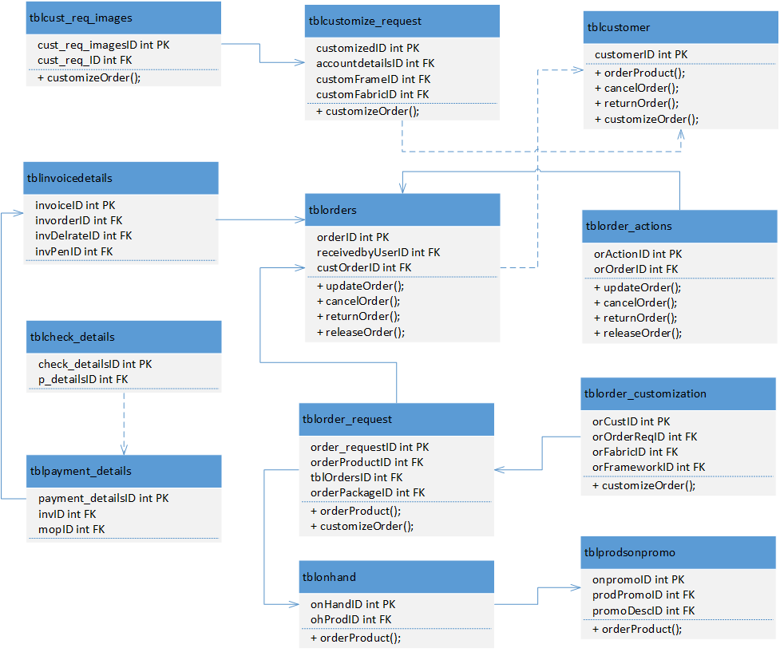

***Figure 3.3.1 Manage Orders Class Diagram***

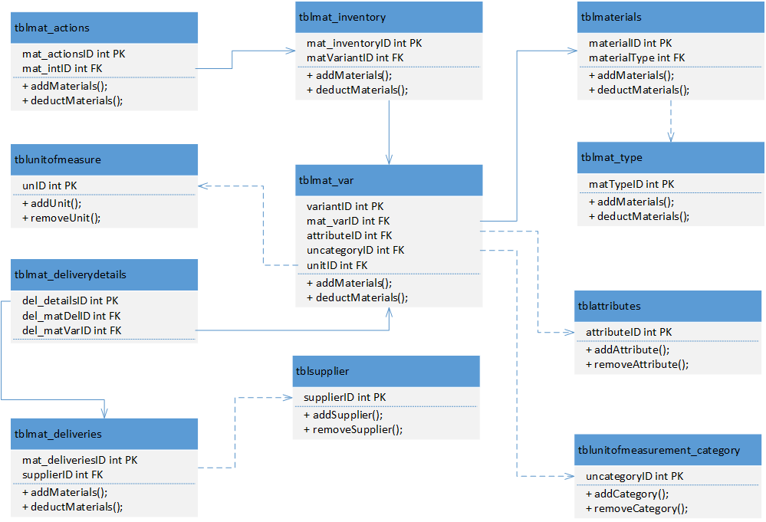

***Figure 3.3.2 Monitor Inventory Class Diagram***

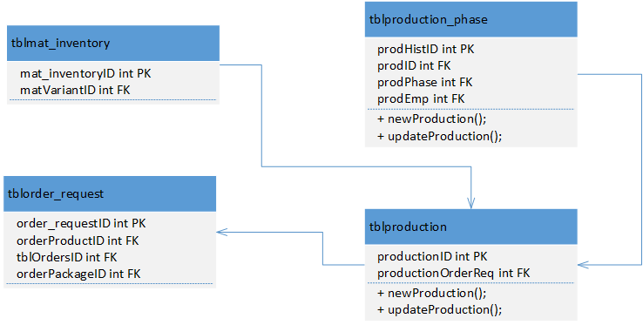

***Figure 3.3. 3 Monitor Production Class Diagram***

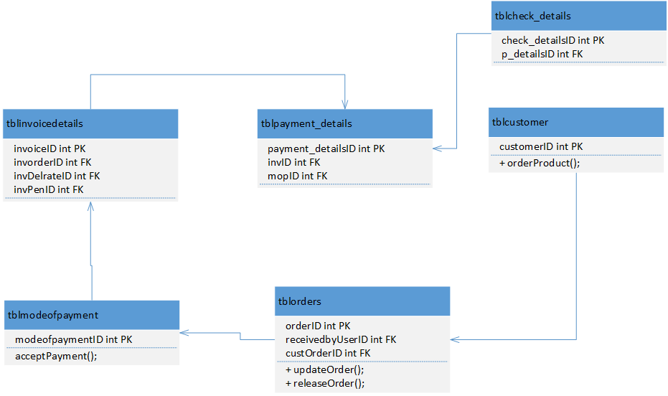***Figure 3.3. 3 Process Payment Class Diagram***

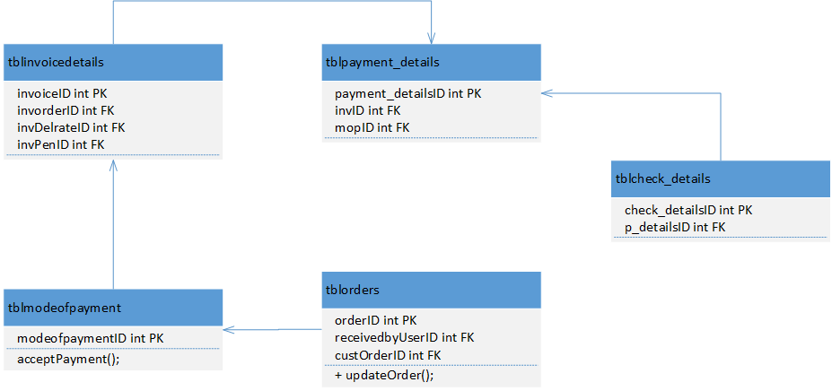

***Figure 3.3. 3 Manage Collections Class Diagram***

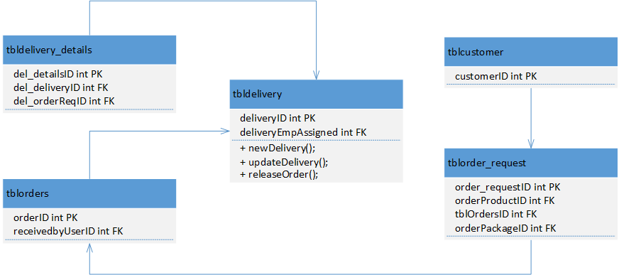

***Figure 3.3. 3 Monitor Delivery Class Diagram***

**3.3.2. Activity Diagram**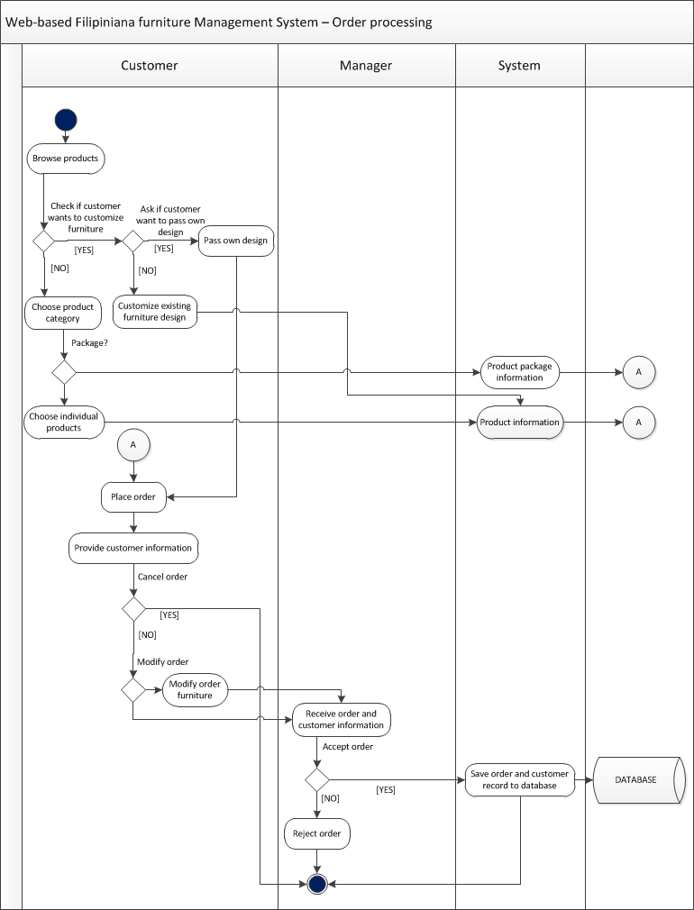

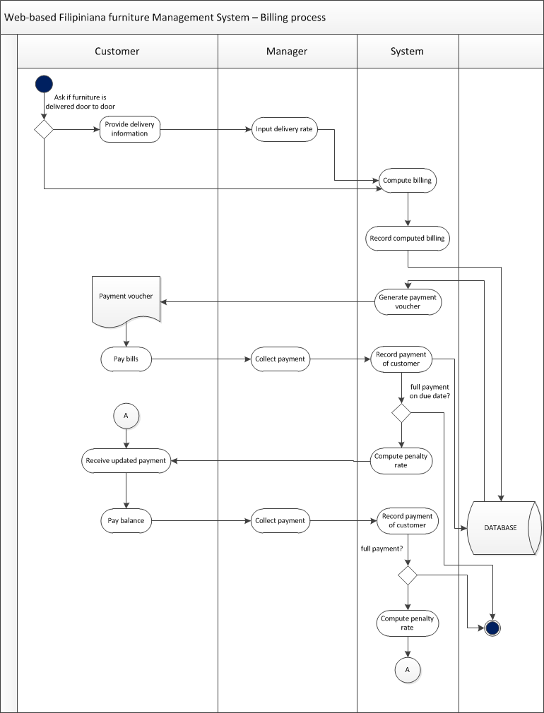





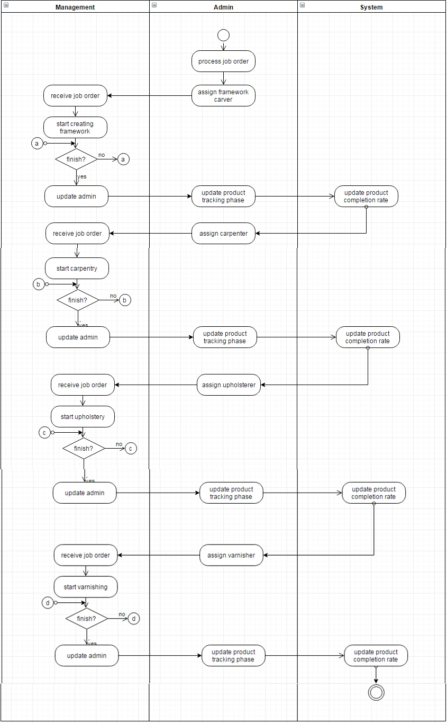Production Tracking

**3.3.3. Database Design**

**3.3.2.1 Database Schema**

